[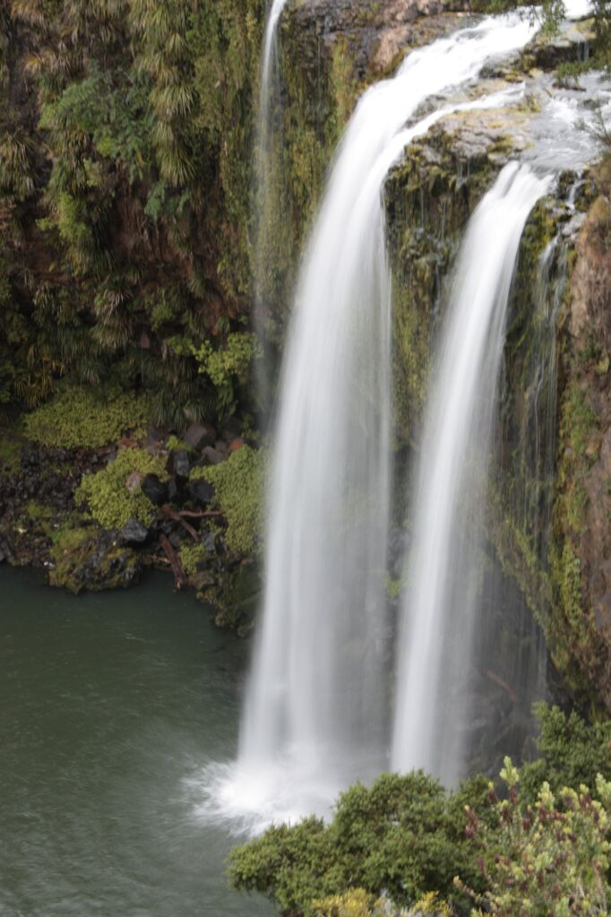](http://www.google.co.nz/url?sa=i&rct=j&q=&esrc=s&source=images&cd=&cad=rja&uact=8&ved=0ahUKEwiSiqalh-TJAhWlLKYKHXbRAjMQjRwIBw&url=http://www.canowindrabusinesschamber.org.au/in-the-news/&bvm=bv.110151844,d.dGY&psig=AFQjCNEWvsNIpuwHHAKMSFyWF_Mmn-Us3A&ust=1450481295804297)



**The Falls Estate Activities**

**July 2020**

94 Boundary Rd

Whangarei 0112

Ph (09) 437 5844

Email: marie.annandale@thebegroup.co.nz

**July Birthdays**

***Laurie Ross 1st Oleen Yendell 16th***

***Ray Yendell 2nd John Harrison 17th***

***Kathy Hay 2nd Sarah Van Der Zypp 18th***

***Lesley Kelly 4th Lynley Horne 19th***

***Faye Jervis 5th Lyn Yendell 20th***

***Karen Thomas 5th Joanne Hanham 21st***

***Mavis Pye 8th Patricia Trouw 22nd***

***Nada Brooke-Anderson 9th Deyal Mckenzie 26th***

***Irene Kerr 9th Grahame Baxendale 27th Arthur Needham 13th Lynne Heatley 27th***

***Sheila Beaton 14th Elaine Penney 28th***

***Bill Johnsen 14th Nola Suester 31st***

[](http://www.google.co.nz/url?sa=i&rct=j&q=&esrc=s&source=images&cd=&cad=rja&uact=8&ved=0ahUKEwj8x6CVq8bTAhXIG5QKHVCODCoQjRwIBw&url=http://dreamquestgames.com/five-hundred-tips-top-10-rules/&psig=AFQjCNF7tgUKfbm2aaYyA-r19uob434spA&ust=1493440918212769)**500 Cards**

Come along and play 500 cards. Every **Monday, 7pm to 8.30pm** in the lounge. Contact **Joan Froggatt: 437-1157.**

**Bolivia**

Do you enjoy playing cards? Join the lovely Bolivia group we have, make some new friends. **Every Tuesday, 1.20pm to 3.30pm** in the lounge. Contact **Libby Townsend: 437-6254.**

**Bridge**

[](http://www.google.co.nz/url?sa=i&rct=j&q=&esrc=s&source=images&cd=&cad=rja&uact=8&ved=0ahUKEwiXzO_Soc3TAhVDn5QKHd7KCrQQjRwIBw&url=http://www.jassshop.ch/ki/Bridge-Karten-92.html&psig=AFQjCNGcE9VY11XC-aqMpUrWAZk_8rkhyg&ust=1493678877437213)Bridge is by far the greatest card game of all, and it can provide immense challenge and enjoyment for the rest of your life. Come along and join in **every Wednesday** in the lounge **12.50pm to 3.00pm**. Contact **Allie Quinn: 437-3548.**

**Brunch/ Lunch Trip**

Join Diana on a jaunt to her favourite “café” at **11.30pm 4th July (Meet at Admin at 11am)** going to **Ruatangata** **Cafe** Put your name down on the notice board. People on the Reserve list will go the next time around, which will be in August. The van fills fast for this outing so get in early **– or take your own car** and join in the fun!Contact **Diana Mehaffy: 027-466-1203.**



**Computer Club**

Providing fast, reliable Wi-Fi Internet to all village residents for only $12.50 per month. Contact **Graham Tiplady: 027-480-5892** for more information.

**Computer Club Meeting**

**Saturday, 11th July at 10.00 am** in the village lounge the computer club is holding a *“What does that do?”* for computer club members and associates only **Graham Tiplady: 027-480-5892.**

**Computer Tune Up Service**

Show your computer some love with a complete tune up for only $60.00. You won’t believe the difference it will make. Contact only **Graham Tiplady: 027-480-5892** for more details.

[](http://www.google.co.nz/url?sa=i&rct=j&q=&esrc=s&source=images&cd=&cad=rja&uact=8&ved=2ahUKEwjC-b_u7vzcAhUVzmEKHQGJBuMQjRx6BAgBEAU&url=http://folksoundguy.blogspot.com/2009/08/mixing-bluegrass-and-old-time-string.html&psig=AOvVaw1bIGP5d4ZHgFyUt8PIFBNe&ust=1534896864265955)**Country/Folk Music Makers**

If you have an interest in simple country or folk music, you are welcome to come along to the Community Lounge on **Sunday, 12th** **July 1.30pm** for an hour. If you would like more information, contact **Trevor or Robyn Prescott: 437-3950**.

**Craft & Chat:**

Craft & Chat

Chat and Craft in the Craft Room **Friday, 31st July at 10am.** Bring your own crafts or just drop in for a chat. Contact **Robyn Boswell: 459-5375 or Ank Mellema: 459-1812.**

[](http://www.google.co.nz/url?sa=i&rct=j&q=&esrc=s&source=images&cd=&cad=rja&uact=8&ved=0ahUKEwj5y6DJpM3TAhVBoZQKHXSRA_0QjRwIBw&url=http://pmhahome.ca/?page_id%3D7092&psig=AFQjCNE7guAG_-ZaWxJHQU-GGtS2-AfaJQ&ust=1493679625387331)**Cribbage**

This game is hundreds of years old, and still provides a fresh playing experience. If you can add up simple numbers to 30 you can play crib (if you can’t, someone will always help you). **Every Tuesday at 2.00pm** in the lounge. Contact **Betty Harding: 437-7607.**

[](http://www.google.co.nz/url?sa=i&rct=j&q=&esrc=s&source=images&cd=&cad=rja&uact=8&ved=0ahUKEwjmm8SgwevJAhWBGKYKHTffBZIQjRwIBw&url=http://www.123rf.com/photo_16552954_mascot-illustration-of-a-dartboard-holding-a-dart.html&psig=AFQjCNEAaOZxPBkO99DD_ZeF3oUbJJBcig&ust=1450737669383041)**Darts**

A dartboard is up in the community dance area. If you would like to play, you will need to bring your own darts.

**Dry Cleaning**

**Collection days are before **9.30am Monday, Wednesday or Friday**. Please bring your garment/s and your payment to **reception** and they will book this in for you. Dry-cleaning costs are available from reception and on the notice board.

**Easy Fun Quiz Night**

Come along for a fun night out and put your mind to the test!  **Thursday, 2nd, 16th and 30th July at 7pm.** Contact **Betty Harding: 437-7607.**

**Flower Arranging Group**

We will meet **Friday,** **10th** **July** **at 10.00am** in the Craft Room. Contact **Jeanette Porter: 027-272-6910.**

**Garden Group**

All gardeners, would-be-gardeners, pot-planters, brown-fingers are welcome to join the Garden Group **Friday, 17th July at 2pm** in the Beehive. Contact **Bette Harrison: 435-6347 or Marilyn Williams: 459-1877.**

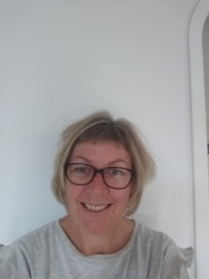**Hairdresser**

Robyn is here every **Tuesday from 9.00am.** Contact **Robyn:**

**021-0220-3924** to make your appointment.

**Hairdresser**

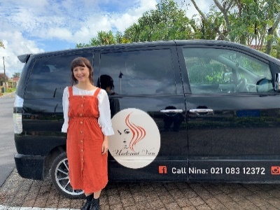Nina is here every **Friday from 9.00am*.*** Contact **Nina: 021-0831-2372** to make your appointment.

**Housie**

All are welcome to come along and try their luck at winning a game! Just **$2** a card which is used for up to 12 games. Prizes vary on how many people are playing, so get a group together and come along and make an evening of it. **Every Wednesday** from **7pm-8.30pm** in the lounge. Contact **Charmaine Beeston: 027-221-5527.**

**‘Hymn Singing for Pleasure’**

[](http://www.google.co.nz/url?sa=i&rct=j&q=&esrc=s&source=images&cd=&cad=rja&uact=8&ved=2ahUKEwjt-Ymk39baAhWFE7wKHdtxBWcQjRx6BAgAEAU&url=http://clipart-library.com/hymn-sing-cliparts.html&psig=AOvVaw1a1BB3hxwaog7rc67xEx8g&ust=1524790977615719)Do you love to sing, just for pleasure? What about your favourite hymns, too? Everyone who fits that description is welcome to a Hymns-Sing-a-long, held in the Community Lounge, **Sunday,** **26th July from 1.30pm - 2.30pm**. Let's enjoy some friendly singing, all your favourites! Need more info?

Contact **Gwendolyn Needham: 437-7183.**

**[](http://www.google.co.nz/url?sa=i&rct=j&q=&esrc=s&source=images&cd=&cad=rja&uact=8&ved=0ahUKEwiivbbrsc3TAhUFJpQKHVJ6A3EQjRwIBw&url=http://www.oxbowls.co.uk/&psig=AFQjCNFF0gGcyyo8VC25Ain4WZfwvJfY-g&ust=1493683028502294)Indoor Bowls**

Come and enjoy a game on our wonderful raised carpets, all are welcome. **Mixed** – **Monday, Friday & Sunday 1.20pm to 3pm**

**Ladies** – **Every Wednesday 1.30pm**

**Men** – **Every Thursday 2pm**

Contact **Jeanette Porter: 027-272-6910.**



**John’s Coffee Morning**

**Saturday, 11th and 25th July at 10.00am.** Come along and enjoy a **FREE** cup of coffee or tea with biscuits to this very popular event. Come and chat with your friends (or meet new ones). If you buy a raffle ticket **$1**. You could even win one of John’s homemade cakes! Contact **John Porter: 027-272-6910.**

[](https://www.google.co.nz/url?sa=i&rct=j&q=&esrc=s&source=images&cd=&cad=rja&uact=8&ved=0ahUKEwjyveTWwM3TAhXGJZQKHS4OBGMQjRwIBw&url=https://u3asites.org.uk/wellingborough/page/21251&psig=AFQjCNHQ7y8SXgn_0pTGtm9d0bELtsuVQA&ust=1493683815417321)[](https://www.google.co.nz/url?sa=i&rct=j&q=&esrc=s&source=images&cd=&cad=rja&uact=8&ved=0ahUKEwjxspiqwM3TAhXEupQKHTEnC0gQjRwIBw&url=https://www.giftwrappedandgorgeous.com/product-knit-and-natter-personalied-mug-perfect-knitters-gift-10103.htm&psig=AFQjCNHQ7y8SXgn_0pTGtm9d0bELtsuVQA&ust=1493683815417321)**Knit & Knatter**

Make new friends over a cuppa, biscuits and a good natter and develop your creative skills. **Every Wednesday from 10am to midday** in the lounge. Contact **Betty Harding: 437-7607.**

**Lunchtime Concert**

The next will be on **Saturday, 4th and 18th July at 11.00am, with Ank.** Come along and enjoy great music on the big screen. Bring your lunch, Tea & Coffee supplied. Contact **Ank Mellema: 459-1812 or Doug Healey: 435-3421.**

[](http://www.google.co.nz/url?sa=i&rct=j&q=&esrc=s&source=images&cd=&cad=rja&uact=8&ved=0ahUKEwic_N33xc3TAhWHspQKHUuGCBIQjRwIBw&url=http://mahjong.frvr.com/&psig=AFQjCNGWwYgWwW59P5evSDDJifBbwEfegg&ust=1493688267966588)**Mahjong**

This is a game of skill, strategy, and calculation and involves a degree of chance. If you would like to give it a go come along to the lounge **Thursdays from 1.30pm.** Contact **Jeanette Porter: 027-272-6910.**

**Magazine Swap Table**

[](http://www.google.co.nz/url?sa=i&rct=j&q=&esrc=s&source=images&cd=&cad=rja&uact=8&ved=0ahUKEwjr0u7tvOvJAhVjHKYKHSIQBccQjRwIBw&url=http://www.gptx.org/Home/Components/Calendar/Event/16735/1748&psig=AFQjCNHIcygxlquYOUb_z1HVlPEUT7kiFQ&ust=1450736494004737)On the raffle table we have a magazine swap section of the last 4 weeks Women’s Day, Women’s Weekly etc. They are there to borrow, but **PLEASE** bring them back when you are finished so that someone else can have a read.

*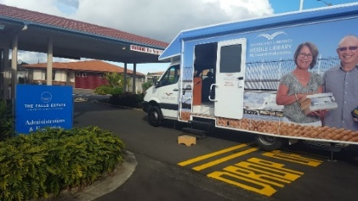***Mobile Library Bus**

The library bus will be in the village on **Thursday, 9th and 23rd July from 2:00pm to 2.30pm**.

**Mosaics**

On Every **Thursday at 9.00am** in the Craftroom. Contact **Trudy McKnight: 027-477-6664.**

**Painting Group “Brush Strokes”**

For those who have dabbled in art in the past and would enjoy rekindling their interest with likeminded people, this group meets on **Wednesdays at 10am** at the Craft Room. Come and discover the creative talent you didn’t know you had! Contact **Bette Harrison: 435-6347.**

[](http://www.google.co.nz/url?sa=i&rct=j&q=&esrc=s&source=images&cd=&cad=rja&uact=8&ved=0ahUKEwjm8LmtyM3TAhVIHJQKHf5fArMQjRwIBw&url=http://basdmobile.boxip.net/quilting-clip-art.html&psig=AFQjCNEvKljPEBBmtpGLUB13w7xHMC2Dfw&ust=1493689260256969)**Patchwork/Quilting**

Come and help make Patchwork quilts for charity. If you can use a sewing machine you can do it! Enjoy a cup of coffee with us and make new friends. Meet in the craft room every **Monday from 9.30am to Midday**. Contact **Joan Froggatt: 437-1157.**



**Petanque**

Come out and play in the fresh air. This well loved game takes place every **Saturday at 1pm.** Contact **Betty Harding: 437-7607.**

**Phase 10All Quilters and Quilters-to-be are welcome!!All Quilters and Quilters-to-be are welcome!!All Quilters and Quilters-to-be are welcome!!**

[](http://www.google.co.nz/url?sa=i&rct=j&q=&esrc=s&source=images&cd=&cad=rja&uact=8&ved=0ahUKEwjx-NaXzc3TAhXEkZQKHfcRDOYQjRwIBw&url=http://www.mattelgames.com/en-us/phase-10/index.html&psig=AFQjCNHS2KILELQLEx_Tho2voa7QVaWkdQ&ust=1493690512990958)Phase 10 is a Rummy Type Card Game with challenging and exciting twists! Held **every Thursday from 1.20pm to 3.30pm** in the lounge. Contact **Jeanette Firman: 022-341-3228.**

**Poetry & Writing**

Creative writing and beautiful Poetry. **Tuesday,** **7th and 21st July.** Contact **Ank Mellema: 459-1812** for more information.

**Podiatrist**

Jo will be available on **2nd, 14th and 30th July from 8:30am** in the Hairport. Contact **Jo: 436-2899** to make an appointment**.**

[](http://www.google.co.nz/url?sa=i&rct=j&q=&esrc=s&source=images&cd=&cad=rja&uact=8&ved=0ahUKEwiZi-Dt183TAhVBNpQKHZ-iBWMQjRwIBw&url=http://keywordsuggest.org/gallery/872724.html&psig=AFQjCNFeQ91gy0WIulJvA0n5NHlzZAz0iQ&ust=1493693392113888)**Scrabble**

Scrabble is a fun, classic word game. Come and join in  **Saturday, 11th & 25thJuly from 10.30am to 1pm**. Contact **Allie Quinn: 437-3548.**

[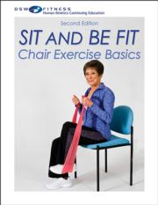](http://www.google.co.nz/url?sa=i&rct=j&q=&esrc=s&source=images&cd=&cad=rja&uact=8&ved=0ahUKEwjGqoWVtuvJAhVGYaYKHTz_BVAQjRwIBw&url=http://www.humankinetics.com/products/all-products/chair-exercise-basics-print-ce-course&psig=AFQjCNH776unT3pkU_ZPETNSct9-v_AFIw&ust=1450734667263645)**Sit Fit Classes**

**Friday at 11.00am**. For a low impact fitness class that is very enjoyable and extremely good for you. The cost is: - **$5** per class. Come along and enjoy! This class is for everyone! Contact **June Douglas: 459-5338**.

[](http://www.google.co.nz/url?sa=i&rct=j&q=&esrc=s&source=images&cd=&cad=rja&uact=8&ved=0ahUKEwjVi9qE5c3TAhWMpZQKHX_sAxEQjRwIBw&url=http://www.mattelgames.com/en-us/skip-bo/index.html&psig=AFQjCNF27aJQ9TQpki2_7TLwtf0NrCSxjA&ust=1493696978542569)**Skip Bo**

Skip-Bo is the ultimate sequencing card game from the makers of UNO. The first player to use all the cards in their stockpile wins. Played **Every Saturday** in the lounge **1.20pm to 3.30pm**. Players are running this activity themselves.

**Snooker**

[](http://www.google.co.nz/url?sa=i&rct=j&q=&esrc=s&source=images&cd=&cad=rja&uact=8&ved=0ahUKEwjj6sf75s3TAhUKjJQKHeW-BSgQjRwIBw&url=http://www.mabooz.com/the-legendary-game-of-snooker/&psig=AFQjCNFDLHlfumQJI81ktoOG2QgdYSOnpA&ust=1493697486296104)We have a great Snooker/Pool table. All are welcome to join in for a game. Held **Monday-Friday from 10.00am to midday** on the dance floor. Use the table any time you like outside this regular session. Contact **Dave Firman: 021-0819-6045.**

**Sunday Golf - (You must be reasonably fit)**

We will be playing 7 holes of ‘Ambrose’ and pay green fees per round, with a social gathering after golf in the lounge back at the village, BYO nibbles and drink. Please bring your own car until further notice. **Every Sunday at 1.30** Contact **Betty Harding: 437-7607.**

[](https://it.123rf.com/photo_17871535_illustrazione-di-stickman-coppie-ballroon-danza.html)**Swing Dancing**

**Tuesday, 11.00am to 12 midday**. For a low impact fitness class that is very enjoyable and extremely good for you. The cost is only **$5**.

Come along and enjoy! Contact **June Douglas: 459-5338.**

[](http://www.google.co.nz/url?sa=i&rct=j&q=&esrc=s&source=images&cd=&cad=rja&uact=8&ved=0ahUKEwif87zV7M3TAhXKmJQKHboBBgAQjRwIBw&url=http://www.nbcolympics.com/table-tennis&psig=AFQjCNExIHdLfb15PzeoyYK0ZAvuUTC9lA&ust=1493699013121726)**Table Tennis**

Enjoy some fun in this low impact sport. Meet **every Wednesday** with your paddles, or ones that can be provided, on the dance floor from **2pm to 3.30pm**. Contact **Pauline van Eybergen:**

**459-4079.**

[](http://www.google.co.nz/url?sa=i&rct=j&q=&esrc=s&source=images&cd=&cad=rja&uact=8&ved=0ahUKEwjfl6zn783TAhUDFJQKHfHEDkkQjRwIBw&url=http://www.eightwaves.co.uk/&psig=AFQjCNGIMOc77wtIWE3T8Rj72sP45HuFFg&ust=1493699543995816)**Tai Chi**

Tai Chi is a fun, low impact and cheap way to improve your health. It would be great to see some new faces! Meet every **Monday from 10am to 11am** in the lounge, cost is only **$5.00**. Contact **Diana Mehaffy: 027-466-1203.**

**Thursday Supermarket Shopping**

**Every Thursday: Leave 9.00am - Pick up at 10.00am.** As we are limited to 9 people for each trip, we ask that you phone Reception to reserve your seat. If you are a regular user of the trips please just let the office know if you are unable to come. Contact **Mary at Reception: 437-5844.**



**Trash & Treasure**

**Saturday, 25th July at 10.00a**[](http://www.google.co.nz/url?sa=i&rct=j&q=&esrc=s&source=images&cd=&cad=rja&uact=8&ved=2ahUKEwjQ_JjMjf_bAhVBkpQKHYEQAjgQjRx6BAgBEAU&url=http://tandt.666forum.com/&psig=AOvVaw3cxyjKWPp8POWVKK-Z1qUb&ust=1530575851381248)**m. H**ave a look and, maybe, buy something off the Trash and Treasure Table where you will find some bargains. Contact **Betty Harding: 437-7607.**

[](https://www.google.co.nz/url?sa=i&rct=j&q=&esrc=s&source=images&cd=&cad=rja&uact=8&ved=0ahUKEwibgvHV8c3TAhVEppQKHSdVAC0QjRwIBw&url=https://freedombaptistrh.sharepoint.com/Pages/Songs.aspx&psig=AFQjCNFoGcVglJV4z-MCF3D8AbvNEgqcag&ust=1493700368602888)**Village Choir**

Come and be a part of the exciting choir performances we have lined up for 2020. Practice is **every Monday** in the lounge **from 3.30pm**. New members are welcome. Contact **Doug Healey: 027-434-1001.**

**Village Library**

All residents are welcome to use the library at any time, just help yourself, no date stamps required. The only thing that is requested is that you return the books ASAP & when you return the books please put them in the RED Bin. Contact **Nola Coleman: 437-7746**

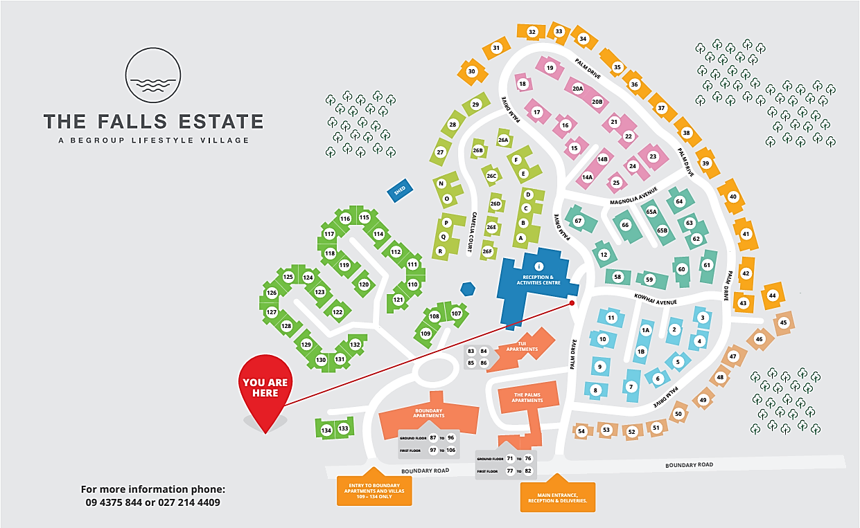

**SATURDAY MOVIES 7PM**



***ICECREAMS AVAILABLE $1***

**SATURDAY 11THJULY**

***THE BOOK CLUB***

**Four friends' lives are turned upside down when their book club tackles the infamous "50 Shades of Grey." From discovering new romance to rekindling old flames, they inspire each other to make their next chapter the best chapter.**

** **SATURDAY 25TH JULY**

***500 DAYS OF SUMMER***

**Tom revisits the approximate one year he shared with summer, the girl he thought he could spend the rest of his life with. She, on the other hand, does not believe in relationships or boyfriends**.

[](https://www.google.co.nz/url?sa=i&rct=j&q=&esrc=s&source=images&cd=&cad=rja&uact=8&ved=2ahUKEwjgysXMnrTdAhXQBIgKHVdRDEIQjRx6BAgBEAU&url=https://www.tillycroyservices.com/hse-industrial-skill-cscs&psig=AOvVaw22PkPNIw8jkSxMuszuMWZV&ust=1536799454859919)**HEALTH AND SAFETY BUILDING & FIRE WARDENS**

[](https://www.google.co.nz/url?sa=i&rct=j&q=&esrc=s&source=images&cd=&cad=rja&uact=8&ved=2ahUKEwjgysXMnrTdAhXQBIgKHVdRDEIQjRx6BAgBEAU&url=https://www.tillycroyservices.com/hse-industrial-skill-cscs&psig=AOvVaw22PkPNIw8jkSxMuszuMWZV&ust=1536799454859919)

**ADMIN BLOCK / COMMUNITY CENTRE**

[](https://www.google.co.nz/url?sa=i&rct=j&q=&esrc=s&source=images&cd=&cad=rja&uact=8&ved=2ahUKEwiS08zDkrTdAhVDUt4KHeiMD6kQjRx6BAgBEAU&url=https://www.assured-ltd.co.uk/blog/staff-given-enough-fire-safety-training-5-steps-ensure/&psig=AOvVaw27OE8FYsRRPFqDlUwWSbv-&ust=1536794630345152)

[](https://www.google.co.nz/url?sa=i&rct=j&q=&esrc=s&source=images&cd=&cad=rja&uact=8&ved=2ahUKEwiS08zDkrTdAhVDUt4KHeiMD6kQjRx6BAgBEAU&url=https://www.assured-ltd.co.uk/blog/staff-given-enough-fire-safety-training-5-steps-ensure/&psig=AOvVaw27OE8FYsRRPFqDlUwWSbv-&ust=1536794630345152)During Office Hours

* Marie Annandale – Building Warden
* Myrn Wild
* Mary Williams

After Office Hours

* John Porter (UN60)
* Dave Firman (UN26F)
* Lew Holmwood (UN26C) - Building Warden

**BOUNDARY APARTMENTS**

* Cecil Hanham (SA104)
* Doug Healey (SA106)
* Trevor Mehaffy (SA092) – Building Warden

[](https://www.google.co.nz/url?sa=i&rct=j&q=&esrc=s&source=images&cd=&cad=rja&uact=8&ved=2ahUKEwiG6766lbTdAhUZIIgKHTEvBTAQjRx6BAgBEAU&url=https://www.skfireprotection.co.uk/fire-training&psig=AOvVaw27OE8FYsRRPFqDlUwWSbv-&ust=1536794630345152)

**PALMS APARTMENTS**

* John Harrison (SA075)– Building Warden

**THE FALLS ESTATE VILLAGE ACTIVITIES**

|  |  |  |  |  |  |  |
| --- | --- | --- | --- | --- | --- | --- |
| ACTIVITY | TEAM LEADER(S) | DAYS | START / FINISH | COST | | WHERE |
| 500 Cards | Joan Froggatt | Monday | 7.00pm to 8.30pm | Free | | Lounge |
| Blokes Shed | John Porter  Kevin Kelly  Ray Bradley | Any day | Anytime | Free | | Blokes Shed |
| Bolivia | Libby Townsend | Tuesday | 1.20pm to 3.30pm | Free | | Lounge |
| Bridge | Allie Quinn | Wednesday | 12.50pm to 3.00pm | Free | | Lounge |
| Brunch Trip | Diana Mehaffy | See noticeboard | | | | |
| Computer Club | Graham Tiplady, Margie Beer, | Anytime | Anytime | Unlimited Broadband $12.50 per month | | |
| Country / Folk Music Makers | Trevor & Robyn Prescott | 2nd Sunday of every month | 1.30pm | Free | Lounge | |
| Cribbage | Betty Harding | Tuesday | 2.00pm | Free | | Lounge |
| Craft & Chat | Ank Mellema  Robyn Boswell | Last Friday of every month | 10am | TBA | | Craft Room |
| Craft Room | Colleen Wech  Joan Froggatt  Bob Somerville-Ryan | Monday to Friday | Anytime | Donation for goods used | | Craft Room |
| Darts |  | Any day | Anytime (BYO darts) | Free | | Dance Area |
| DVD / CD Library | Dave Firman | Any day | Anytime | Free | | DVD / CD Library |
| Easy Fun Quiz | Betty Harding | 1st, 3rd & 5th Thurs | 7.00pm to 8.30pm | Free | | Lounge |
| Flower Arranging | Jeanette Porter | 2nd Friday | 10.am | TBA | | Craft Room |
| Garden Group | Bette Harrison  Marilyn Williams | 3rd Friday | 2pm | TBA | | Beehive |
| Genealogy | Jeanette Porter | Contact Jeanette UN060 if you would like to be part of a new group. | | | | |
| Hairdresser | Robyn | Tuesdays | From 9am |  | | Hairport |
| Hairdresser | Nina | Fridays | From 9am |  | | Hairport |
| Housie | Charmaine Beeston | Wednesday | 7.00pm to 8.30pm | $2.00 a game | | Lounge |
| Hymn Singing for Pleasure | Gwendolyn Needham | 4th Sunday | 1.30pm – 2.30pm | Free | | Lounge |

|  |  |  |  |  |  |  |  |
| --- | --- | --- | --- | --- | --- | --- | --- |
| ACTIVITY | TEAM LEADER(S) | | DAYS | | START / FINISH | COST | WHERE |
| Indoor Bowls Mixed | Jeanette Porter | Mon, Fri & Sun | | 1.20pm to 3.00pm | | Free | Indoor Bowls Area |
| Indoor Bowls Ladies Only | Every Wed | | 1.30pm | | Free | Indoor Bowls Area |
| Indoor Bowls Men Only | Every Thurs | | 2.00pm | | Free | Indoor Bowls Area |
| John’s Coffee Morning | John Porter | 2nd & 4th Saturday | | 10am | |  |  |
| Jig Saws | Jeanette Firman | Any day | | Anytime | | Free | Lounge |
| Knit & Knatter | Betty Harding | Wednesday | | 10am to midday | | Free | Lounge |
| Library | Nola Coleman | Any day | | Anytime | | Free | Lounge |
| Lunch Time Concert | Ank Mellema  Doug Healey | 1st & 3rd Saturday | | 11.00am to 1.00pm | |  | Lounge |
| Mahjong | Jeanette Porter | Thursday | | 1.30pm | | Free | Lounge |
| Meditation | Ank Mellema | Any day | | Anytime | | Free | See Ank |
| Mosaics | Ank Mellema or Bob Somerville-Ryan | Thursday | | 9.00am | | TBA | See Ank or Lesley |
| Movies | Bob Somerville-Ryan | 1st & 3rd Sat | | 7.00pm to 9.00pm | | $1.00 ice cream | Lounge |
| Painting | Bette Harrison | Wednesday | | 10.00am | | TBA | Craft Room |
| Patchwork / Quilting | Joan Froggatt | Monday | | 9.30 to midday | | TBA | Craft Room |
| Petanque | Bette Harrison | Saturday | | 1pm | | Free | Petanque court |
| Phase 10 | Jeanette Firman | Thursday | | 1.20pm to 3.30pm | | Free | Lounge |
| Poetry & Writing | Ank Mellema | 2nd & 4th Tues | | 1.30pm to 3.30pm | | Free | Lounge |
| Restaurant open | Amber Wallace | Fridays | | 5.30 onward | | $6.50-$17 | Restaurant |
| Scrabble | Allie Quinn | 2nd & 4th Sat | | 10.30am to 1.00pm | | Free | Lounge |
| Sit Fit | June Douglas | Friday | | 11.00am | | $5.00 | Lounge |
| Skip Bo | Run by players | Saturday | | 1.20pm to 3.30pm | | Free | Lounge |

|  |  |  |  |  |  |  |  |
| --- | --- | --- | --- | --- | --- | --- | --- |
| ACTIVITY | TEAM LEADER(S) | | DAYS | | START / FINISH | COST | WHERE |
| snooker | Dave Firman | Mon to Fri | | 10.00am to midday | | Free | Dance Floor |
| Sunday Golf | Betty Harding | Sunday | | 1.30 | | $7.00 | Decide on day |
| Swing Dancing | June Douglas | Tuesday | | 11.00am to 12.00pm | | $5.00 | Dance Floor |
| Table Tennis | Pauline van Eybergen | Wednesday | | 2.00pm to 3.30pm | | Free | Dance Floor |
| Tai Chi | Diana Mehaffy | Monday | | 10.00am to 11.00am | | $4.00 | Lounge |
| Trash & Treasure | Betty Harding | Every 4th Sat of the month | | 10.00am | |  | Lounge |
| Van Outings | See office for bookings | **See calendar for details or noticeboard** | | | | | |
| Village Choir | Doug Healey | Monday | | 3.30pm | |  | Lounge |
| Welfare | Diana Mehaffy | Any day | | Anytime | | Free | Mobile  027 466 1203 |