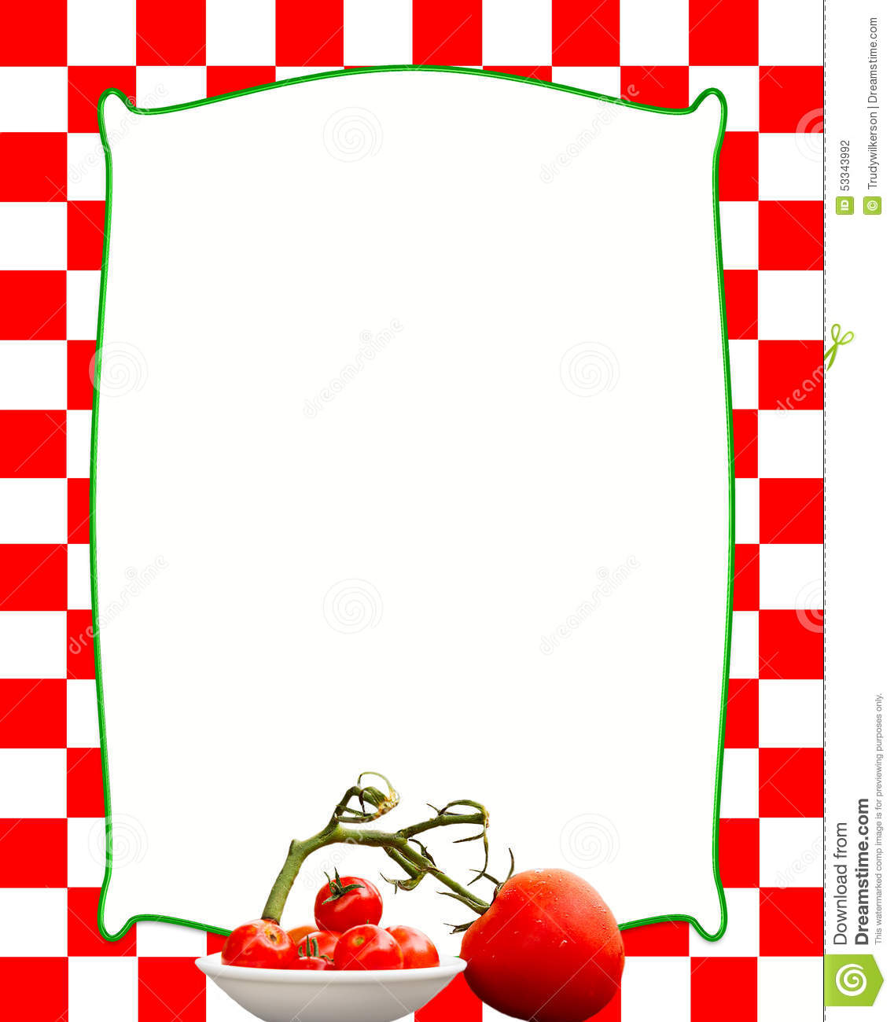-----------

cid:image001.jpg@01D640AD.75C47EE0

**Friday 6th November**

***$17***

**Bobotie, Cumin and Cloves Spiced Minced Beef with a Creamy Backed Egg Topping served with Home-grown Garden Salad**

***$6.50***

**Lemon Delicious Pudding served with a dollop of Custard**

**All produce is spray free, organic, and locally grown. Meat sourced from Omak’s Kamo.**

**Dry goods are from Kamo Bin Inn, and Pac n Save.**

**Please have names booked in by**

**Thursday 11am**

**CASH ONLY PAYMENT**

***Note: Where possible,***

***Smaller portions can be accommodated***

***at $8.50 per meal***